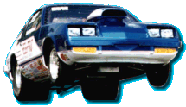
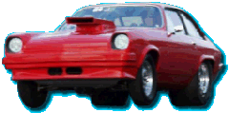
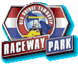

1st Annual H-Body Meet
Sponsored by v8monza.com
at Old Bridge Township Raceway Park
(a.k.a. Englishtown Raceway)
at Englishtown, N.J.
Sunday November 10, 2002
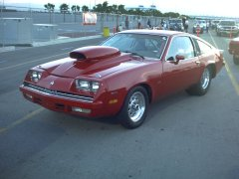
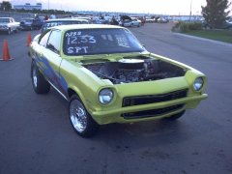
All 1971 - 1980 GM H-Bodies are welcome!
(Monzas, Vegas, Cosworths, Astres, Sunbirds, Skyhawks, Nighthawks, and Starfires)
Gates open at 8:00 AM
Time Trials start at 10:00 AM
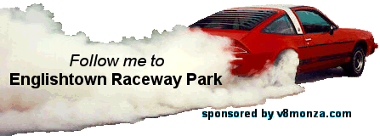
http://www.etownraceway.com
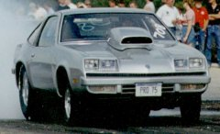
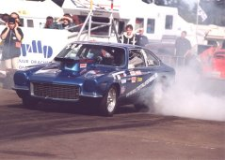
For more information, contact:
Bill Lynch
(631) 831-9434

